Continental Introduces Spanish Language Version of REDI-Sensor Website
- Site includes training content, where to buy info, application look up
- Developed to service growing population of Spanish speaking technicians
Allentown, PA, January 14, 2025 – Continental has launched a Spanish language version of its popular REDI-Sensor tire pressure monitoring system (TPMS) website. The site, which can be found at redi-sensor.com/es, was developed to support the growing number of Spanish-speaking technicians in the United States and act as an information hub for technicians and shops.
“We heard from more and more of the customers we visit that a Spanish language website would be a valuable resource for shops and technicians,” notes Denzel Lall, Technical Training Specialist at Continental. “The REDI-Sensor website hosts a wealth of information including TPMS FAQs, training assets and videos, and crucial TPMS tool update downloads that are essential to successful TPMS service. Adding a Spanish language option will ensure that even more professionals have access to these helpful assets.”
The REDI-Sensor.com website offers application look up, where to buy, training, installation and relearn instructions, as well as information and downloads to help technicians keep their TPMS tool software up to date. It is now available in both English and Spanish languages.

Continental develops pioneering technologies and services for sustainable and connected mobility of people and their goods. Founded in 1871, the technology company offers safe, efficient, intelligent, and affordable solutions for vehicles, machines, traffic, and transportation. In 2023, Continental generated sales of €41.4 billion and currently employs around 200,000 people in 56 countries and markets.
Drawing on more than 120 years of cooperation with vehicle manufacturers, Continental offers a broad range of spare parts in OEM quality for the aftermarket. Under brands like Continental, ATE, VDO, REDI-Sensor, Autodiagnos, Uniroyal, Semperit, and GALFER, the technology company manufactures tens of thousands of products, including tires, brakes, drive components and thermal management components. It also provides diagnostic solutions, tools and services for repair shops. Continental is one of the most important suppliers in the independent automotive aftermarket.
Press contact

Anouré V. Fenstermaker
Head of Marketing Communications
Continental Automotive Aftermarket, North America
6755 Snowdrift Road, Allentown, PA 18106
Tel: 610-390-4000
Email: anoure.fenstermaker@continental.com

Image and caption
[Image: Continental-REDI-Sensor-Website-SP.jpg]
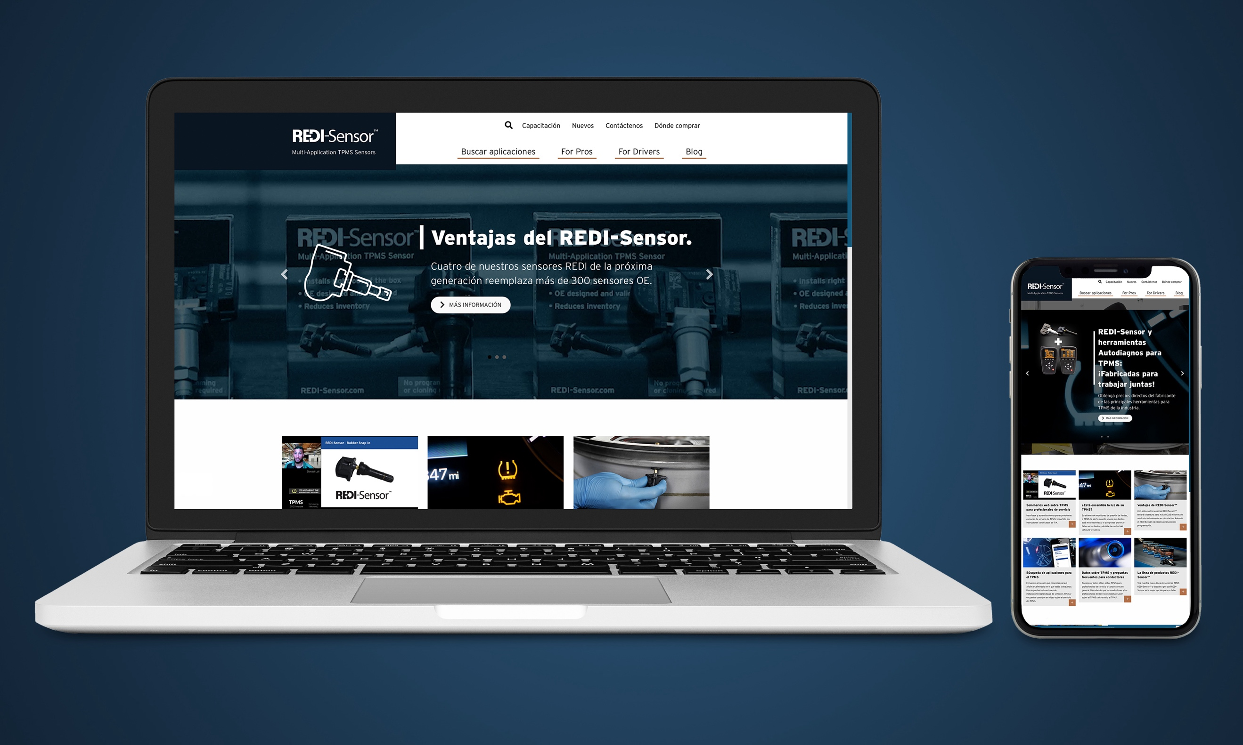
[Caption]
The new Spanish language version of REDI-Sensor.com offers helpful tools to aid TPMS service

